Benha University  Faculty of Engineering - Shoubra  Electrical Engineering Department  First Year (Power) تخلفات |  | Final Term Exam  Date: 20 / 12 / 2014  Fundamentals of Electrical Engineering  Total Duration : 3 hours
First Page
- Answer all the following question | - Mark of the 1st Page : 50
- Illustrate your answers with sketches when necessary. | - Total Mark: 100 Marks
- The exam. Consists of two pages | - The first Page time: 1.5 hours

1.a) For the circuit shown in Fig. 1, find the Norton's equivalent circuit between the two points A and B. Then convert to Thevenin’s equivalents.
( 10 Marks)

1.c) By Millman's Theorem, find the voltage drop and the dissipated power across R4 for the circuit shown in Fig. 3. Then find the value of R4 to obtain the maximum power transferred; then find this maximum Power.
{ R1 = 2, R2 = 10, R3 = 8, R4 = 4 and R5 = 12 all in Ohms and E1 = 40, E2 = 80 Volt} ( 10 Marks)

2.a) Calculate the current taken by a 300 Watt lamp from a 220 Volt supply, also determine the conductance of the lamp filament. How can you measure all parameters used in the problem. ( 8 Marks)

2.b) A series R- L- C circuit has R = 10 Ohm, L = 10 mH and C = 1000 μf, a supply of 220 Volt, 60 Hz is applied, calculate: the supply current, the power factor, the voltage across each element, the value of each type of the power, sketch the power and the impedance diagrams.
For the condition of resonance, find the resonance frequency fr, XL, XC and the current I. Sketch XL, XC and I versus fr. ( 16 Marks)
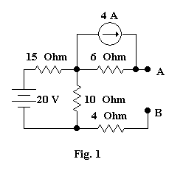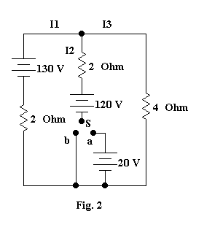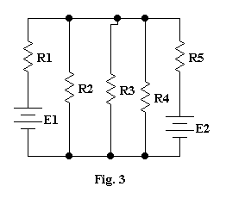
من فضلك تابع بقية الأسئلة
مع أمنياتي بالتوفيق و النجاح &
ا.د. محمد مؤنس

